**DAILY ONLINE ACTIVITIES SUMMARY**

|  |  |  |  |  |  |  |  |  |
| --- | --- | --- | --- | --- | --- | --- | --- | --- |
| **Date:** | **04-06-2020** | | | | | **Name:** | **pallavi** | |
| **Sem & Sec** | **6th A** | | | | | **USN:** | **4al17cs056** | |
| **Online Test Summary** | | | | | | | | |
| **Subject** | | **OS** | | | | | | |
| **Max. Marks** | | **30** | | **Score** | | | **15** | |
| **Certification Course Summary** | | | | | | | | |
| **Course** | **Introduction to cloud** | | | | | | | |
| **Certificate Provider** | | | **Cognitive**  **class IBM** | | **Duration** | | | **10hr** |
| **Coding Challenges** | | | | | | | | |
| **Problem Statement:**  1.take two strings, return a string of the form short+long+short, with the shorter string on the outsides and the longer string on the inside. The strings will not be the same length, but they may be empty  2.Write a Java program to implement Queue Using Array And Class | | | | | | | | |
| **Status:completed** | | | | | | | | |
| **Uploaded the report in Github** | | | | | **yes** | | | |
| **If yes Repository name** | | | | | <https://github.com/pallavi056/DAILY_STATUS> | | | |
| **Uploaded the report in slack** | | | | | **yes** | | | |

Online Test Details:

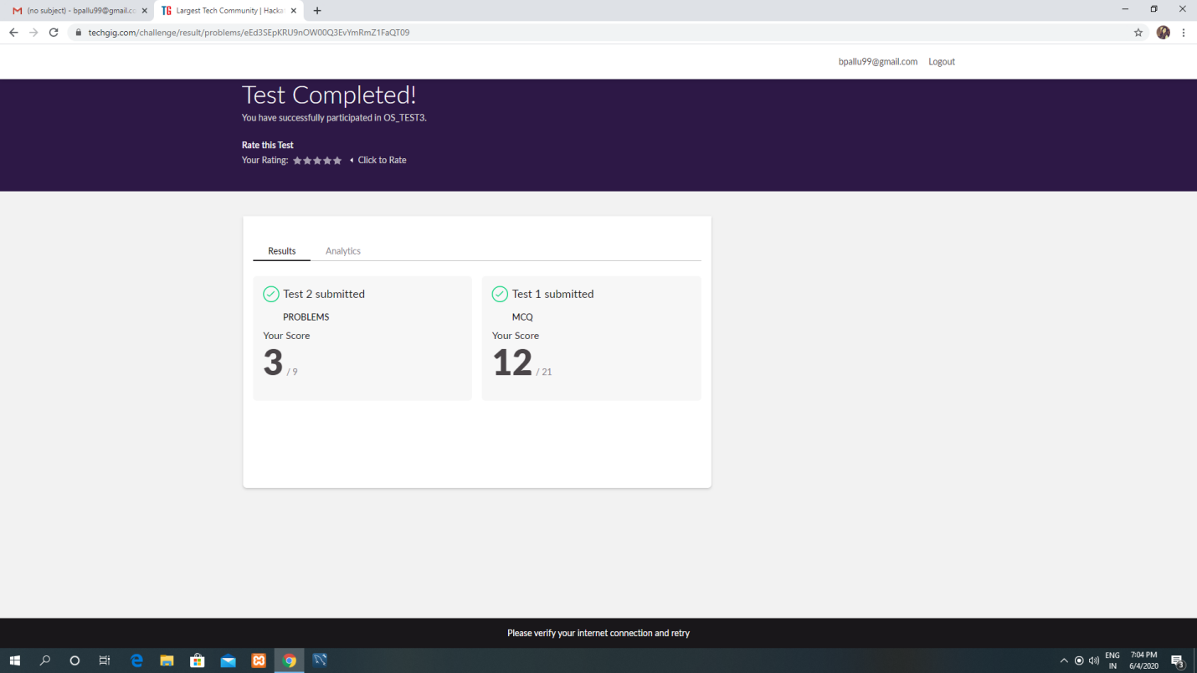

Certification Course Details:

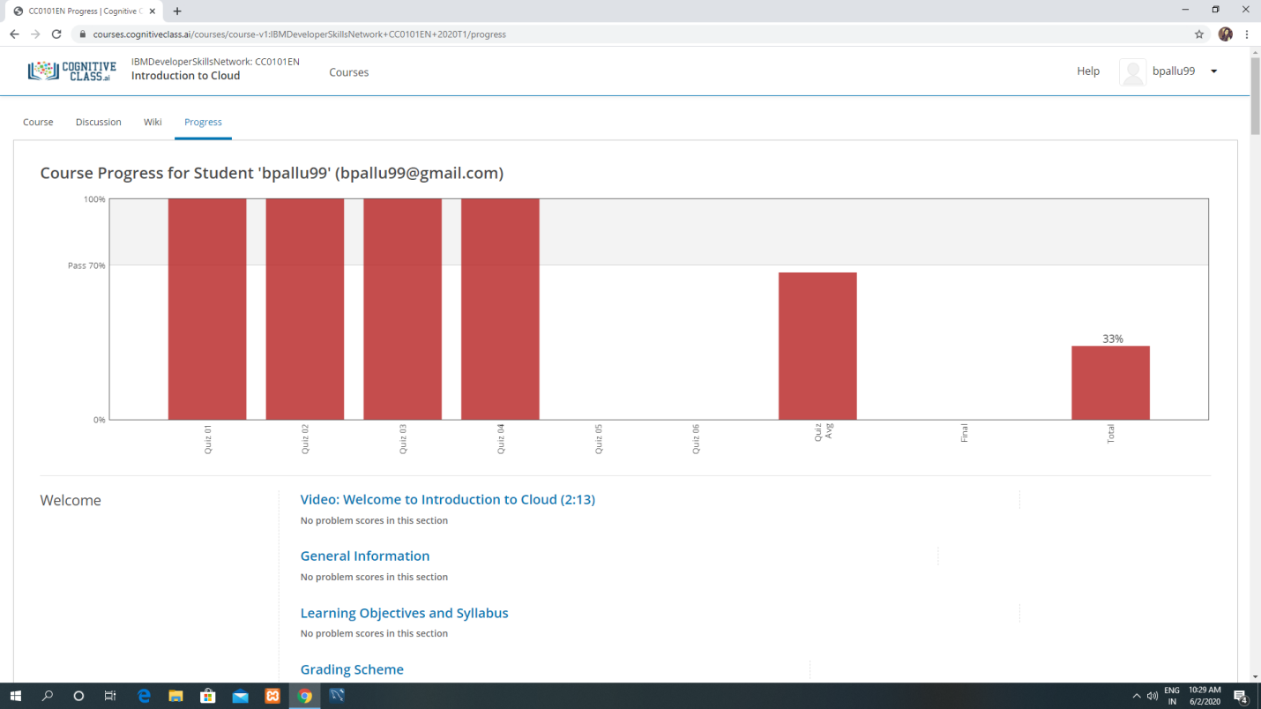

Coding Challenges Details:

[https://github.com/pallavi056/DAILY_STATUS/tree/master/04-06-2020/ONLINE%20CODING](https://github.com/pallavi056/DAILY_STATUS/tree/master/04-06-2020/ONLINE CODING)